AI statement:
In these bonus questions, I used AI tools (Gemini) as a learning assistant. Specifically, I used AI to:
1. Help me better understand the questions requirements.
2. Get suggestions on which points to choose
3. Optimize my written text answers for better clarity.

Bonus Question (a)
ANSWER:
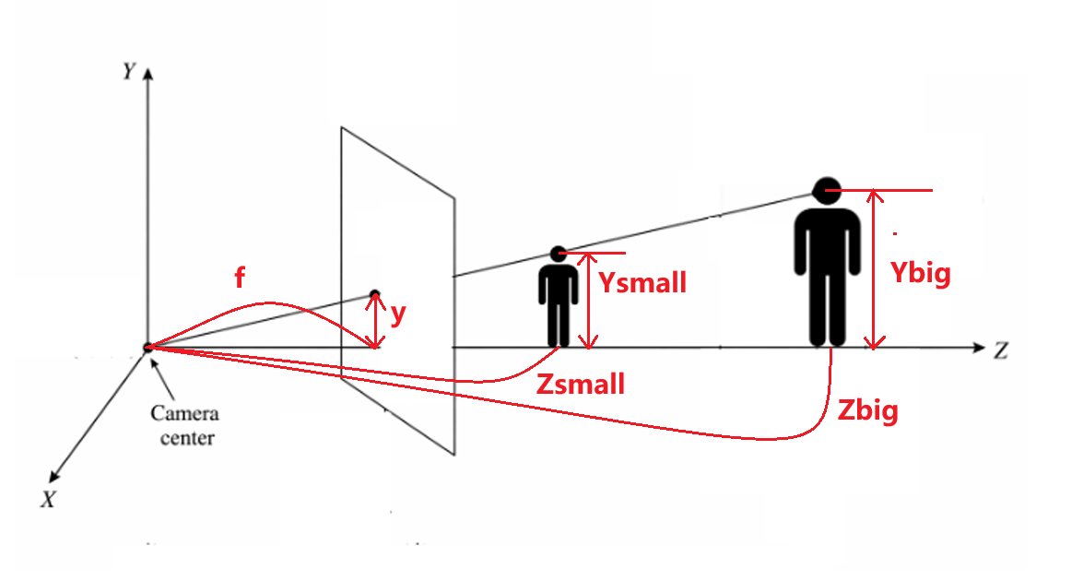
$y=f\frac{Y}{Z}$ (Similar triangles)
Assume the adult's height is s times that of the child, and the distance from the camera is also s times. That is: $Y_{big}=s⋅Y_{small}$, and $Z_{big}=s⋅Z_{small}$. The projection height $y_{big}$ of the adult on the image is:
$$y_{big}=f\frac{Y_{big}}{Z_{big}}=f\frac{s⋅Y_{small}}{s⋅Z_{small}}=f\frac{Y_{small}}{Z_{small}}=y_{small}$$
This proves that no matter how much the 3D scene is magnified or reduced $s$, as long as the distance changes proportionally, its projected coordinates $x,y$ on the 2D image remain unchanged.
Scale ambiguity means that it is fundamentally impossible to determine the absolute, real-world size of an object or its exact distance from the camera using just a single photograph.
As shown in the marked figure, if you have a small object placed close to the camera and a giant object placed far away, they can both block the exact same amount of the camera's field of view. The lights originating from the top and bottom of both objects hit the image plane at the exact same spots.
Because the projection process discards depth, we lose the ability to judge true scale unless there is a familiar reference object (like a car or a person) in the scene to provide context.

Bonus Question (b)
ANSWER:
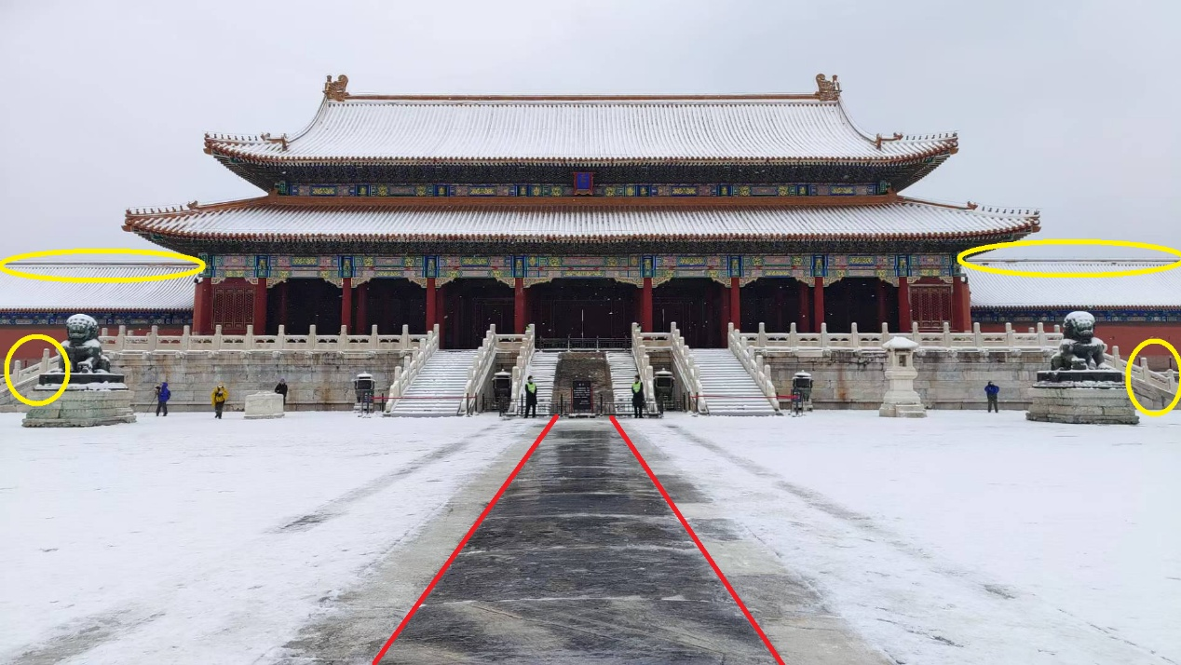
Explained Phenomenon: Converging Parallel Lines (Marked in Red)
- Assumption holds: In the marked area, the architectural lines that are strictly parallel to each other in the real world are projected in a way that they appear to converge towards a single vanishing point. This directly illustrates the core assumption of the ideal pinhole camera model. The model assumes that all lights travel in straight lines through a single point (the camera center) before hitting the planar image sensor.
- Image Geometry Effect: As a result of this perspective projection, straight 3D lines are preserved as straight 2D lines. Furthermore, parallel lines receding into the distance which are not parallel to the image plane will geometrically intersect at a vanishing point on the 2D image plane.
Not Explained Phenomenon: Slight Radial Lens Distortion (Marked in Blue)
- Assumption violated: In the marked area, the architectural lines are not perfectly straight line. The ideal pinhole model theoretically assumes a projection through an infinitely small pinhole without any optical lenses. In the real world, cameras must use glass lenses to gather sufficient light, which introduces hardware limitations.
- Image Geometry Effect: The physical lens causes barrel distortion in wide-angle shots, where the refractive index varies depending on the distance from the optical center. This violates the rule that "straight lines always project as straight lines," causing the image geometry to slightly warp and curve near the borders.

